## HW2 Skiplist

1. 概率p相同时，不同长度跳表的搜索路径长度均值
2. p = 1/2

|  |  |  |  |  |  |  |
| --- | --- | --- | --- | --- | --- | --- |
| 跳表长度 | 10 | 50 | 100 | 200 | 500 | 1000 |
| 路径长度 | 7.3 | 11.3 | 13.5 | 15.9 | 18.0 | 20.0 |

1. p = 1/e

|  |  |  |  |  |  |  |
| --- | --- | --- | --- | --- | --- | --- |
| 跳表长度 | 10 | 50 | 100 | 200 | 500 | 1000 |
| 路径长度 | 7.7 | 10.3 | 12.2 | 15.9 | 19.4 | 17.4 |

1. p = 1/4

|  |  |  |  |  |  |  |
| --- | --- | --- | --- | --- | --- | --- |
| 跳表长度 | 10 | 50 | 100 | 200 | 500 | 1000 |
| 路径长度 | 5.8 | 10.4 | 12.3 | 17.5 | 17.1 | 19.0 |

1. p = 1/8

|  |  |  |  |  |  |  |
| --- | --- | --- | --- | --- | --- | --- |
| 跳表长度 | 10 | 50 | 100 | 200 | 500 | 1000 |
| 路径长度 | 6.7 | 11.6 | 14.1 | 17.7 | 18.8 | 24.2 |

1. p = 1/16

|  |  |  |  |  |  |  |
| --- | --- | --- | --- | --- | --- | --- |
| 跳表长度 | 10 | 50 | 100 | 200 | 500 | 1000 |
| 路径长度 | 6.5 | 11.4 | 14.9 | 18.1 | 23.4 | 26.5 |

1. 跳表长度相同时，不同概率p跳表的搜索路径长度均值
2. n = 10

|  |  |  |  |  |  |
| --- | --- | --- | --- | --- | --- |
| 概率p | 1/2 | 1/e | 1/4 | 1/8 | 1/16 |
| 路径长度 | 7.8 | 7.7 | 5.9 | 6.7 | 6.5 |

1. n = 50

|  |  |  |  |  |  |
| --- | --- | --- | --- | --- | --- |
| 概率p | 1/2 | 1/e | 1/4 | 1/8 | 1/16 |
| 路径长度 | 11.3 | 10.3 | 10.5 | 11.6 | 11.4 |

1. n = 100

|  |  |  |  |  |  |
| --- | --- | --- | --- | --- | --- |
| 概率p | 1/2 | 1/e | 1/4 | 1/8 | 1/16 |
| 路径长度 | 13.5 | 12.3 | 12.3 | 14.1 | 14.9 |

1. n = 200

|  |  |  |  |  |  |
| --- | --- | --- | --- | --- | --- |
| 概率p | 1/2 | 1/e | 1/4 | 1/8 | 1/16 |
| 路径长度 | 15.9 | 15.9 | 17.4 | 17.8 | 18.1 |

1. n = 500

|  |  |  |  |  |  |
| --- | --- | --- | --- | --- | --- |
| 概率p | 1/2 | 1/e | 1/4 | 1/8 | 1/16 |
| 路径长度 | 17.9 | 18.9 | 17.2 | 18.8 | 23.3 |

1. n = 1000

|  |  |  |  |  |  |
| --- | --- | --- | --- | --- | --- |
| 概率p | 1/2 | 1/e | 1/4 | 1/8 | 1/16 |
| 路径长度 | 19.9 | 17.4 | 19.0 | 24.2 | 26.4 |

计算得理论值

|  |  |  |  |  |  |  |
| --- | --- | --- | --- | --- | --- | --- |
| 跳表长度/概率p | 10 | 50 | 100 | 200 | 500 | 1000 |
| 1/2 | 6.6 | 11.2 | 13.2 | 15.2 | 17.9 | 19.9 |
| 1/e | 6.3 | 10.6 | 12.5 | 14.4 | 16.9 | 18.7 |
| 1/4 | 6.6 | 11.2 | 13.2 | 15.2 | 17.9 | 19.9 |
| 1/8 | 8.8 | 15.0 | 17.7 | 20.3 | 23.9 | 26.5 |
| 1/16 | 13.8 | 22.5 | 26.5 | 30.5 | 35.8 | 39.8 |

作图见下页

图1 概率p相同，不同跳表长度的平均搜索路径长度折线图

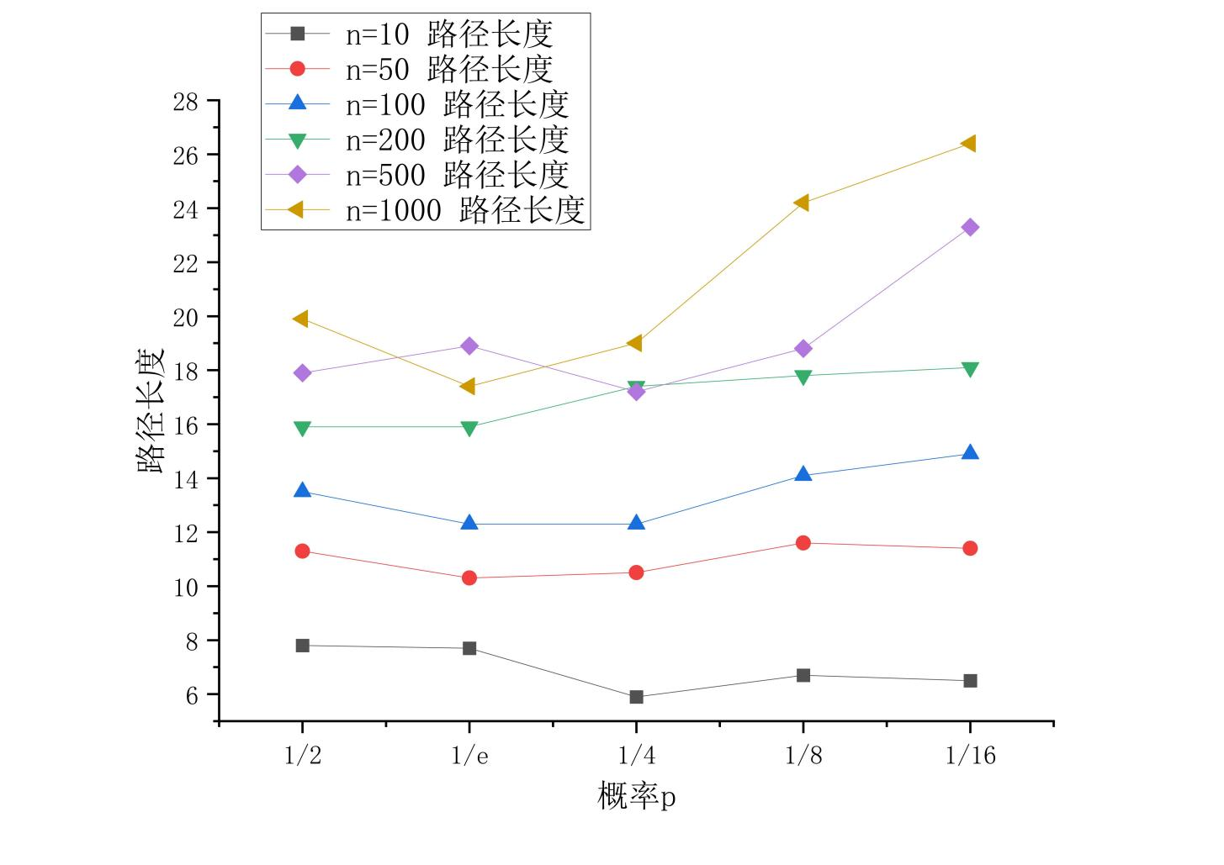

由折线图和实验数据与理论数据的比较可知，实验所得的平均搜索路径长度普遍小于理论计算出的平均搜索路径长度，而增长趋势和不同跳表长度下平均搜索路径长度的相对关系基本相同，可认为其符合理论情况。在n=500，p=1/e处的数据较为反常，推测可能是跳表MaxLevel的设置有所不当引起的。

图2 跳表长度相同，不同概率p的平均搜索路径长度折线图

